M.ANUSIYA

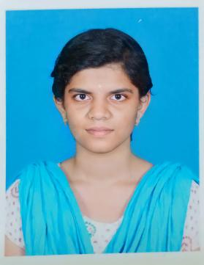

Phone no : 8754891839
Email ID : anusiyam52@gmail.com

OBJECTIVE

- To obtain a challenging position to the best utilization of my skills and looking for oppurtunities to grow my technical and managerial skills and ready to fulfill organizational goals.

ACADEMIC DETAILS

SPECIFICATION | PASSING YEAR | INSTITUTION | STREAM | PERCENTAGE
B.E | 2023 | Annapoorana Engineering College | Computer Science and Engineering | 7.81  CGPA
HSC | 2019 | Tagore Matric Higher Secondary School | Bio Maths | 77%
SSLC | 2017 | Govt. Girls Higher Secondary School | General | 97%

TECHNICAL SKILLS

- Programming languages : C , C++ , Basics in JAVA
- Frontend : Basics in HTML,CSS
- Backend : PHP
- Database : Basics in MYSQL
- MS office
- Handle “Turbo c” software and “visual studio”.

OTHER SKILLS

- Ability to work both independently and as a team player.

STRENGTH

- Good listener
- Quick learner
- Positive attitude

ACHIEVEMENTS

- Attended one week inplant training in “Techforge Academy”.
- Attended one day industrial visit in “codebind Technologies” in Coimbatore.
- Completed certificate course in “Advanced Diploma in Java Programming(ADJP)” with 5 month course duration.
- Completed certificate course in “Mobile app development”.
- I have done a mini project “Temperature and Humidity monitoring system”.

PERSONAL DETAILS

DATE OF BIRTH : 15.10.2001

GENDER : Female

MARITAL STATUS : Single

ADDRESS : Attur, Salem-636001

LANGUAGES KNOWN

TAMIL : (read,write,speak)

ENGLISH : (read,write,speak)

DECLARATION

I hereby declare that all the information furnished above is correct and best to my knowlwdge.

DATE :

PLACE : Salem

Signature

M.Anusiya

